./

GENESIS - Learning Outcome & Shadow Project Summary Report



|  |  |  |  |  |
| --- | --- | --- | --- | --- |
| **Ver. Rel. No.** | **Release Date** | **Prepared. By** | **To be Reviewed By** | **Remarks/Revision Details** |
| 1. | 08-12-2020 | Milind Mohapatra,  Y Sushank | Veeresh Tonne & Achukatala Shaik |  |
| 2. | 17-12-2020 | Milind Mohapatra,  Y Sushank | Veeresh Tonne & Achukatala Shaik |  |
|  |  |  |  |  |
|  |  |  |  |  |
|  |  |  |  |  |

**Details**

# Contents

Contents 3

Table of Figures 4

Table of Tables 4

Modules 5

Topic and Subtopics 5

Objectives 5

Requirements 6

High-level requirement: 6

Low Level Requirement: 6

Design 7

Test Plan 8

Workload Model 10

Implementation Summary 11

Week 1 11

Week 2 11

Week 3 11

Week 4 11

Test Results 12

Challenges faced 13

References 13

# Table of Figures

Figure 1 Demoblaze test architecture 7

Figure 2: SSC Portal Test Report 12

Figure 3: DemoBlaze Test Report 12

# Table of Tables

Table 1 High level requirements 6

Table 2 Low level requirements 6

Table 3 Demoblaze test plan 9

Table 4 Demoblaze workload model 10

Table 5 Project plan 11

# Modules

* Performance testing
* JMeter
* Performance monitoring tools (JProfiler & PerfMon)

# Topic and Subtopics

* Recording JMeter scripts
* Parameterization with CSV data config element
* Dummy test data preparation
* Stepping thread group
* Report generation
* Distributed load testing
* Performance monitoring tools
* Test execution scheduling script

# Objectives

* Evaluating basic of STLC knowledge
* Environment setup: JMeter Installation along with necessary plugins.
* POC Documenting: Understanding functionality and Communication with the application under test with JMeter
* Work Load module creation: will help you out to design the scenarios by specifying number of users and number of transactions.
* Recording and enhancements: Learn on how to record the scripts using JMeter and convert it into effective re-usable test cases.
* Test data preparation: Learn on how to prepare static data set for execution.
* Scenario design and execution: Learn scenario designing and execution process.
* Reporting and Analysis: Creation of customized test execution reports and analyzing the report to identify the bottlenecks
* Recommendations: Sharing report and bottlenecks to respective team

# Requirements

## High-level requirement:

|  |  |
| --- | --- |
| **ID** | **Description** |
| HL_01 | Environment setup – Java and JMeter installation along with custom thread group plugin. |
| HL_02 | Understanding the AUT |
| HL_03 | Developing the performance test scripts. |
| HL_04 | Generation of test execution reports |
| HL_05 | Distributed load testing scripts |
| HL_06 | Performance monitoring tools |
| HL_07 | Test execution script |

Table High level requirements

## Low Level Requirement:

|  |  |
| --- | --- |
| **ID** | **Description** |
| HL_01_L_01 | Installing Java |
| HL_01_L_02 | Installing JMeter with custom thread group plugin |
| HL_02_L_01 | Understand and learning to develop the scripts for interacting with the application. |
| HL_03_L_01 | Record the scripts using JMeter |
| HL_03_L_02 | Modifying recorded scripts with stepping thread groups |
| HL_04_L_01 | Generating CSV and HTML reports |
| HL_05_L_01 | Setup controller node and worker node |
| HL_05_L_02 | Run test on multiple worker nodes for distributing system resources |
| HL_06_L_01 | Performance monitoring using JProfiler and PerfMon |
| HL_07_L_01 | Reusable bash script for running JMeter test scripts and generating reports |

Table Low level requirements

# Design

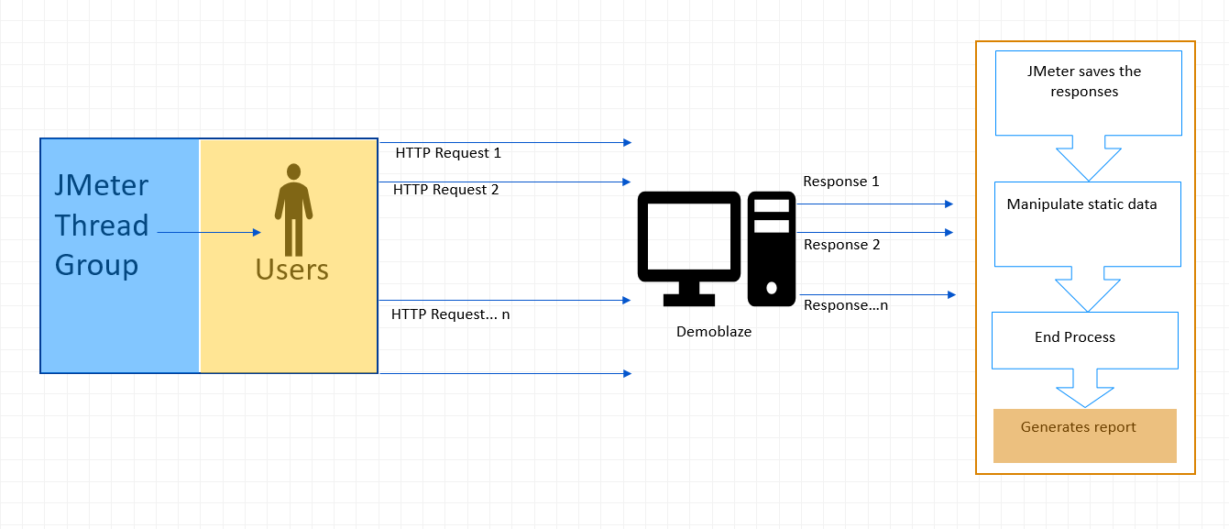

Figure Demoblaze test architecture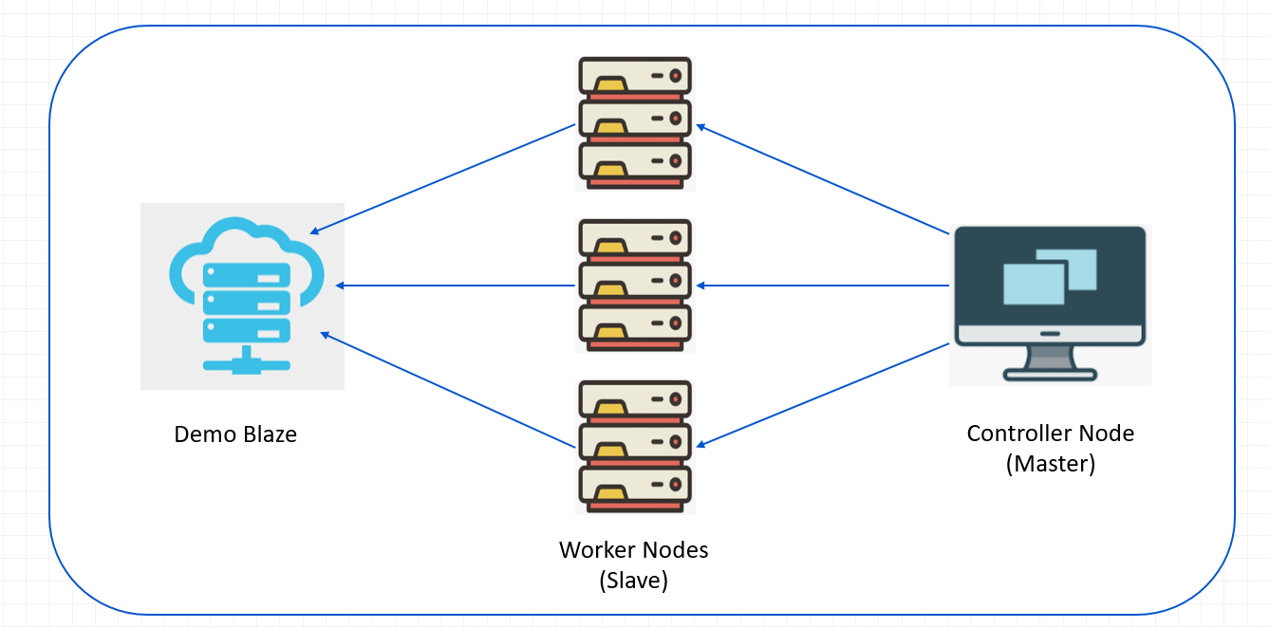

Figure Distributed load testing architecture

# Test Plan

|  |  |  |  |  |  |
| --- | --- | --- | --- | --- | --- |
| **Category** | **TC ID** | **Title** | **Pre-condition** | **Steps (Step)** | **Steps (Expected results)** |
| Launch | TC_01_01 | Launch home | 1. Access to the AUT 2. Internet access | 1. Enter URL in browser 2. Press enter key | 1. Should allow to enter URL in browser 2. Home page should launch |
| Login | TC_02_01 | Login valid user credential | Login page should be open | 1. Enter valid user credentials 2. Click on Login button | 1. User details should be filled in  2. User should login |
| TC_02_02 | Login with valid username but invalid password | Login page should be open | 1. Enter valid username 2. Enter invalid password 3. Click on Login button | 1. Valid username should be entered 2. Invalid password should be entered 3. User should be prompted for wrong invalid password error |
| TC_02_03 | Login with invalid username but valid password | Login page should be open | 1. Enter invalid username 2. Enter valid password 3. Click on Login button | 1. Valid username should be entered 2. Invalid password should be entered 3. User should be prompted for invalid username error |
| TC_02_04 | Login with invalid user credentials | Login page should be open | 1. Enter invalid username 2. Enter invalid password 3. Click on Login button | 1. Valid username should be entered 2. Invalid password should be entered 3. User should be prompted for invalid username error |
| Browse laptops | TC_03_01 | Browse laptops | Laptop category should be available | 1. Go to category section 2. Click on Laptops | 1. Category section should be available 2. Laptop option should be available |
| Select MacBook Pro | TC_04_01 | Select MacBook Pro | Browse laptop category should be available | 1. Find the MacBook Pro in list of Laptops 2. Click on the MacBook Pro | 1. MacBook Pro should be available in the list of laptops 2. MacBook Pro product page should open |
| Add to cart | TC_05_01 | Add to cart option | 1. MacBook Pro product page should be available 2. Add to cart button should be enabled | Click on add to cart button | Added to cart prompt message should be displayed and MacBook Pro should be added to the cart |
| View cart | TC_06_01 | View the cart page | Cart should be available | Click on the view cart button | Cart page should open and any items added to the cart should be visible with price information |
| Place order | TC_07_01 | Place order | 1. Cart should be available 2. Products added to the cart should be visible | 1. Click on place order button 2. Enter address details 3. Pay for the product | 1. Order placed message should pop up and order should be placed 2. Address details should be entered 3. Payment should be successful |
| Logout | TC_08_01 | Logout | User should be logged in | Click on logout button | User should be logged out |

Table Demoblaze test plan

# Workload Model



Table Demoblaze workload model

# Implementation Summary

|  |  |  |  |  |  |  |  |  |  |
| --- | --- | --- | --- | --- | --- | --- | --- | --- | --- |
| **S No.** | **Tasks** | **W1** | **W2** | **W3** | **W4** | **W5** | **W6** | **W7** | **W8** |
| 1 | Team Onboarding, Requirement Analysis & Understanding |  |  |  |  |  |  |  |  |
| 2 | Tool Understanding & Environment Setup |  |  |  |  |  |  |  |  |
| 3 | Application understanding and Design of manual test cases |  |  |  |  |  |  |  |  |
| 4 | Creating workflow model |  |  |  |  |  |  |  |  |
| 5 | Script development and Test data preparation |  |  |  |  |  |  |  |  |
| 6 | Execution and Reporting |  |  |  |  |  |  |  |  |
| 7 | Evaluation and final presentation |  |  |  |  |  |  |  |  |

Table Project plan

## Week 1

* Installation of Java and JMeter
* Introduction to Performance Testing Life Cycle
* Getting familiar with various elements of JMeter

## Week 2

* Recording JMeter scripts
* Parameterization with CSV data config element
* Dummy test data preparation
* Testing of SSC portal for single and multiple users

## Week 3

* Installation of Postman
* Test script design of iBEMS application from postman collection
* Testing of demoblaze.com for multiple users

## Week 4

* Adding custom thread groups through plugins
* Testing of SSC portal and demoblaze using stepping thread group and generating report
* Test execution from terminal (non-GUI mode) to save on resources
* Distributed load testing
* Performance monitoring
* Test execution script

# Test Results

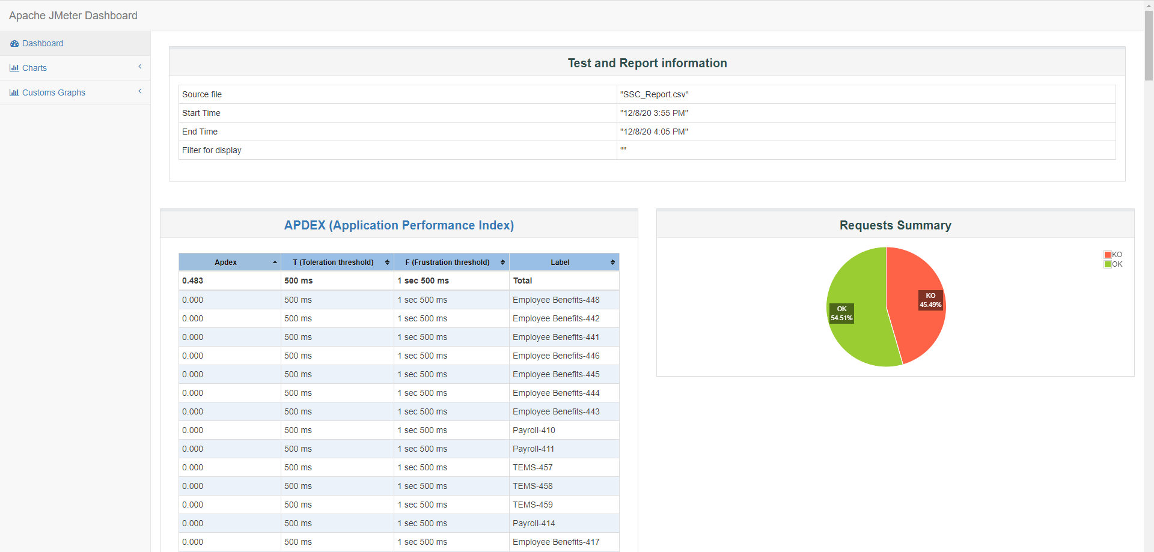

Figure : SSC Portal Test Report

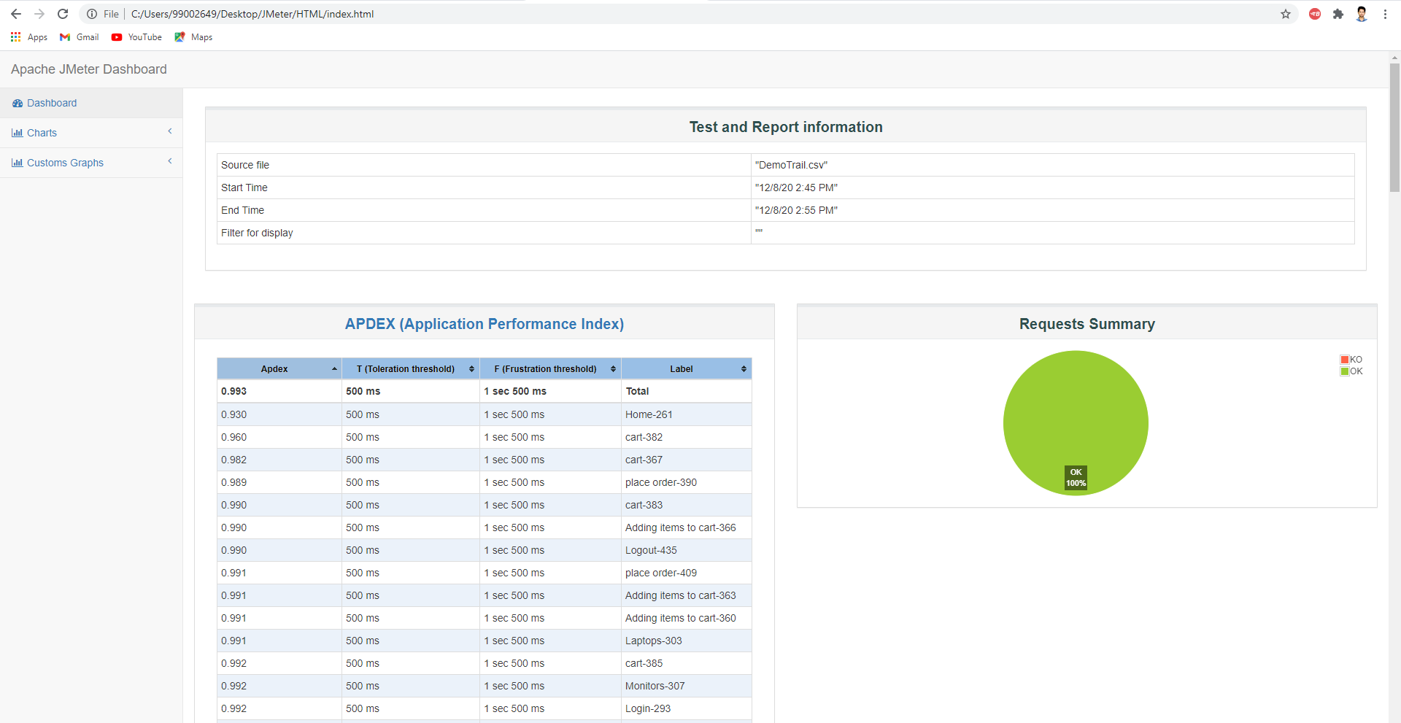

Figure : Demoblaze Test Report

# Challenges faced

* Lack of access to end application, iBEMS, due to the application being moved to intel environment.

# References

* <https://www.guru99.com/performance-testing.html>
* <https://www.tutorialspoint.com/jmeter/jmeter_test_plan_elements.htm>
* <https://www.guru99.com/jmeter-performance-testing.html>
* <https://itnext.io/load-testing-using-apache-jmeter-af189dd6f805>
* <https://stackify.com/ultimate-guide-performance-testing-and-software-testing/#:~:text=Metrics%20are%20needed%20to%20understand,made%20unless%20there%20are%20measurements.&text=Metrics%20%E2%80%94%20A%20calculation%20that%20uses,total%20response%20time%2Frequests>).
* <https://medium.com/@innakozak/performance-testing-metrics-what-needs-to-be-considered-a3ab7995cf1a>
* <https://www.guru99.com/performance-testing.html>
* <https://www.blazemeter.com/blog/jmeter-parameterization-the-complete-guide>
* <https://www.blazemeter.com/blog/how-to-create-test-data-in-a-database-with-jmeter>
* <https://jmeter.apache.org/usermanual/jmeter_proxy_step_by_step.html>
* <https://docs.microsoft.com/en-us/sql/relational-databases/performance/monitor-and-tune-for-performance?view=sql-server-ver15>
* <https://www.edureka.co/blog/performance-testing-life-cycle/>
* <https://www.perfmatrix.com/performance-testing-life-cycle/>
* <https://www.postman.com/downloads/>
* <https://www.guru99.com/complete-web-application-testing-checklist.html>
* <https://www.blazemeter.com/blog/dear-abby-blazemeter-how-do-i-run-jmeter-non-gui-mode>
* <https://www.blazemeter.com/blog/how-use-jmeter-assertions-three-easy-steps>
* <https://raygun.com/blog/server-performance-metrics/>
* <https://jmeter.apache.org/usermanual/jmeter_distributed_testing_step_by_step.html>
* <https://www.perfmatrix.com/server-failed-to-start-java-rmi-server-exportexception/>
* <https://www.windowscentral.com/how-use-performance-monitor-windows-10>
* <https://www.ej-technologies.com/products/jprofiler/overview.html>